**HW # 9: Theme: Advanced Procedures, Stack Parameters, Locals and BCD**

*(All main questions carry equal weight.  Credit awarded to only those answers for which work has been shown.)*

1. Write a procedure named *Arithmetic Expression which computes X=A-B + C.* The 32-bit variables A, B, and C must be passed as value to the stack.  The  value X should be returned on the top of the stack upon return from the procedure and its address must be returned as reference in the register EDI of the program.
2. .386
3. .model flat,stdcall
4. .stack 4096
5. ExitProcess proto, dwExitCode:dword
6. include Irvine32.inc
7. .data
9. aValue byte "Enter value for A: ",0
10. bValue byte "Enter value for B: ",0
11. cValue byte "Enter value for C: ",0
12. ans byte "The answer is: ",0
13. .code
14. main proc
15. mov edx, offset aValue ; get a value
16. call WriteString
17. call ReadInt
18. push eax
19. mov edx, offset bValue ; get b value
20. call WriteString
21. call ReadInt
22. push eax
23. mov edx, offset cValue ; get c value
24. call WriteString
25. call ReadInt
26. push eax
27. mov ebx, 10
28. call ArithmeticExpression
29. mov eax, [edi]
30. mov edx, offset ans
31. call WriteString
32. call WriteInt
33. call crlf
34. exit
35. main endp
36. ArithmeticExpression proc
37. pop ebx
38. pop edx
39. pop eax
40. add eax, edx
41. pop edx
42. sub eax, edx
43. push eax
44. mov edi, esp
45. push ebx
46. ret
47. ArithmeticExpression endp
48. end main 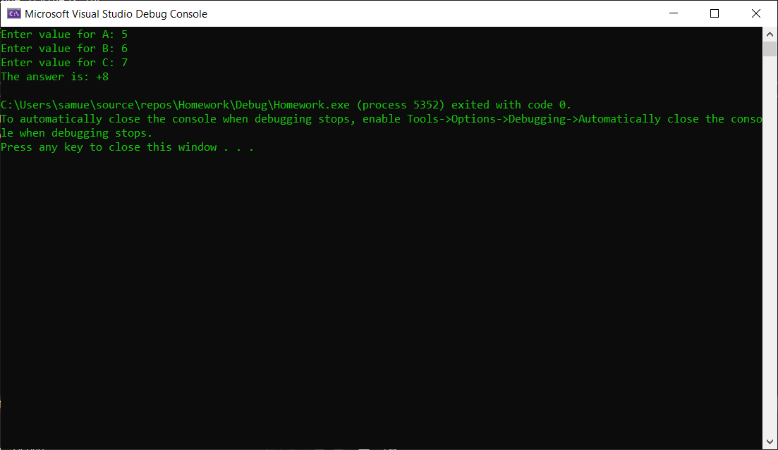

2. Draft a program that subtracts two 8-digit BCD numbers.  Please display the two input 8-digit numbers and the result on the screen.  Please try 3 different 8-digit numbers.

.386

.model flat,stdcall

.stack 4096

ExitProcess proto, dwExitCode:dword

include Irvine32.inc

.data

value1 dword 00009999h

value2 dword 00001000h

value3 dword ?

.code

main proc

mov eax, value1

call WriteHex

call crlf

mov eax, value2

call WriteHex

call crlf

mov eax, value1

mov ebx, value2

sub eax, ebx

das

mov value3, eax

call WriteHex

call crlf

main endp

end main

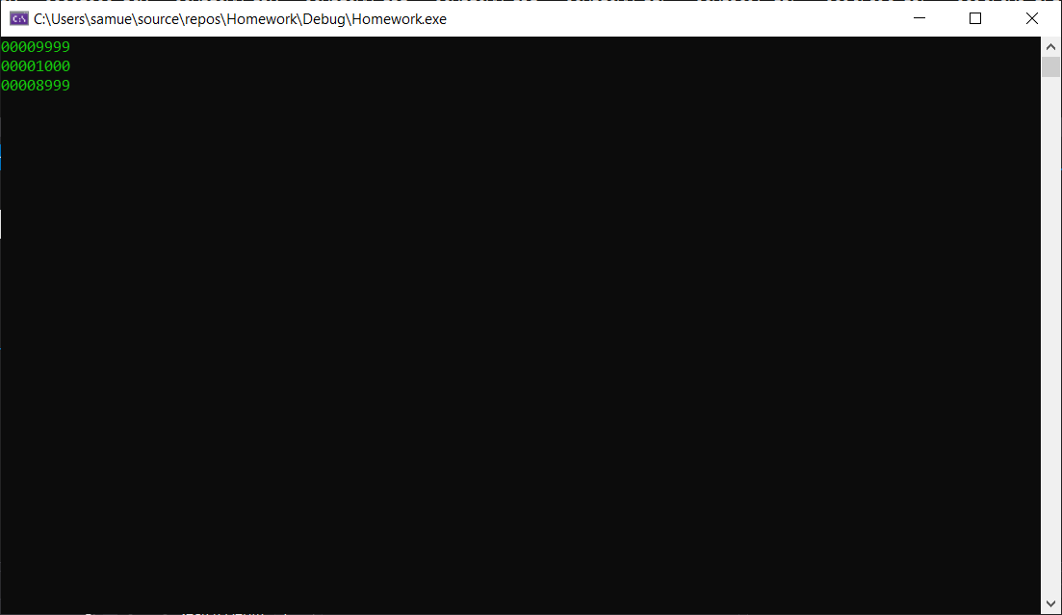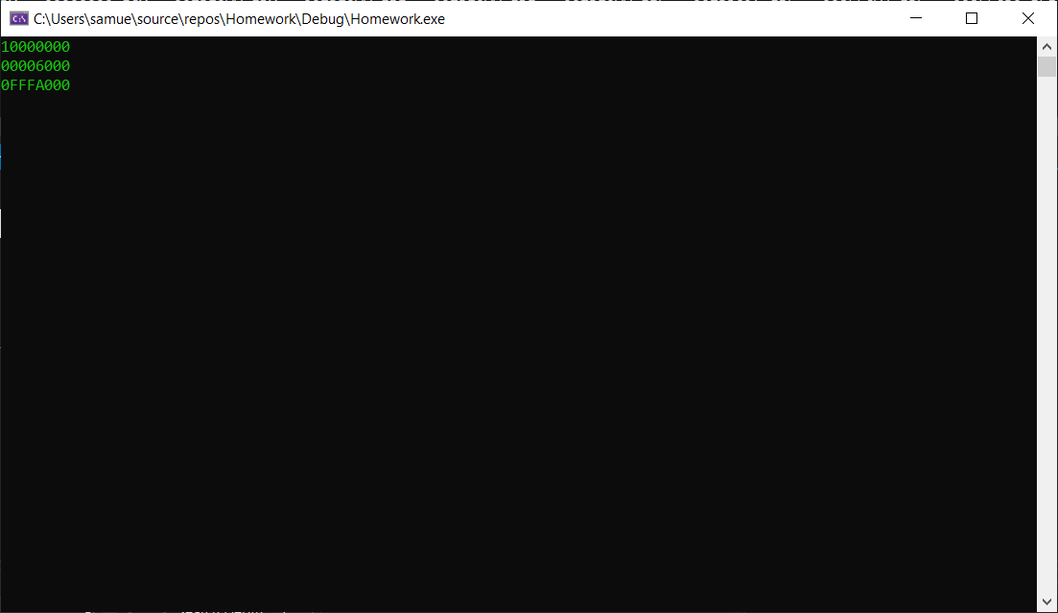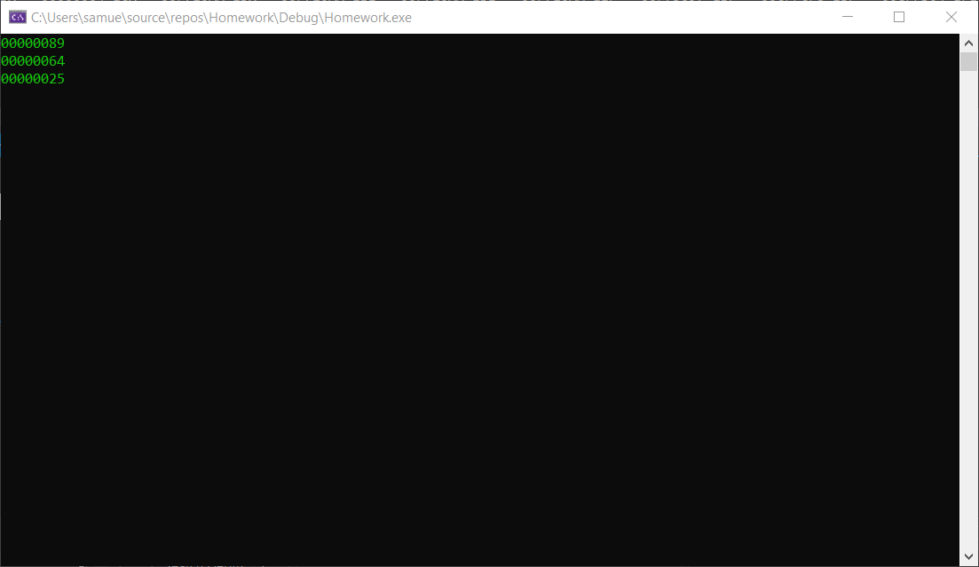

Please embed your code into your homework solution along with a screen shot post execution.